Class test-2 (CSA2075-C Programming)

22/02/3024-Thursday

1. Find the Number of Integers Divisible by 5

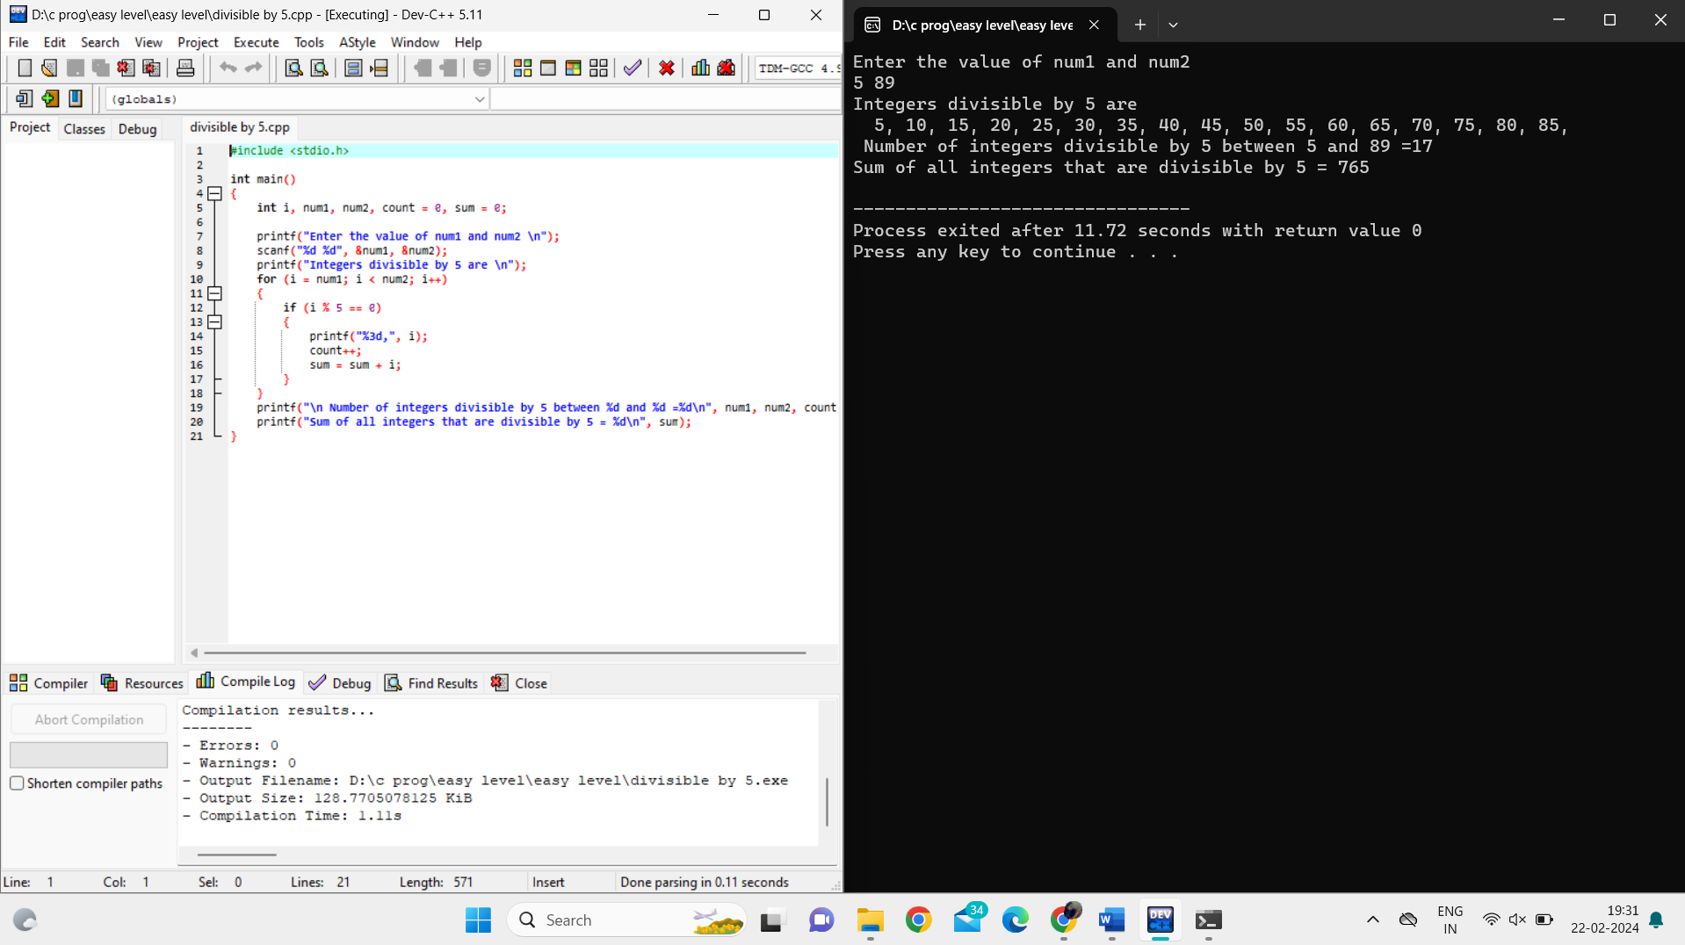

1. Check if Two Numbers are Equal

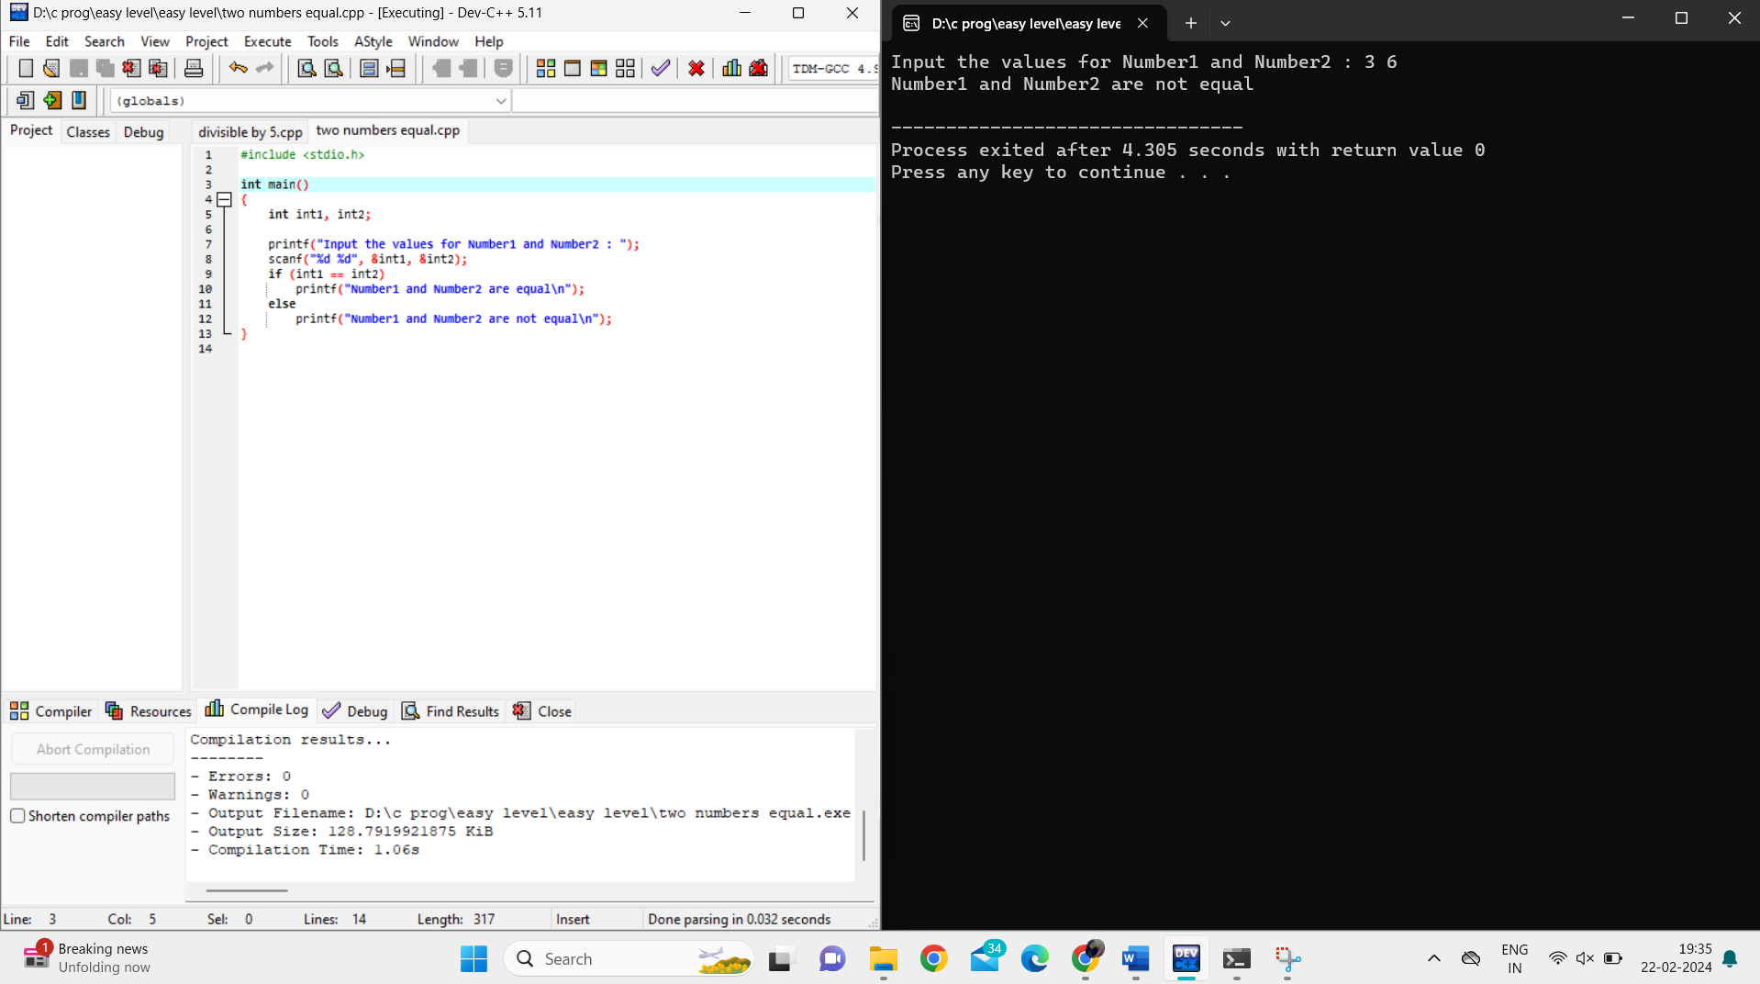

1. Sum of Digits

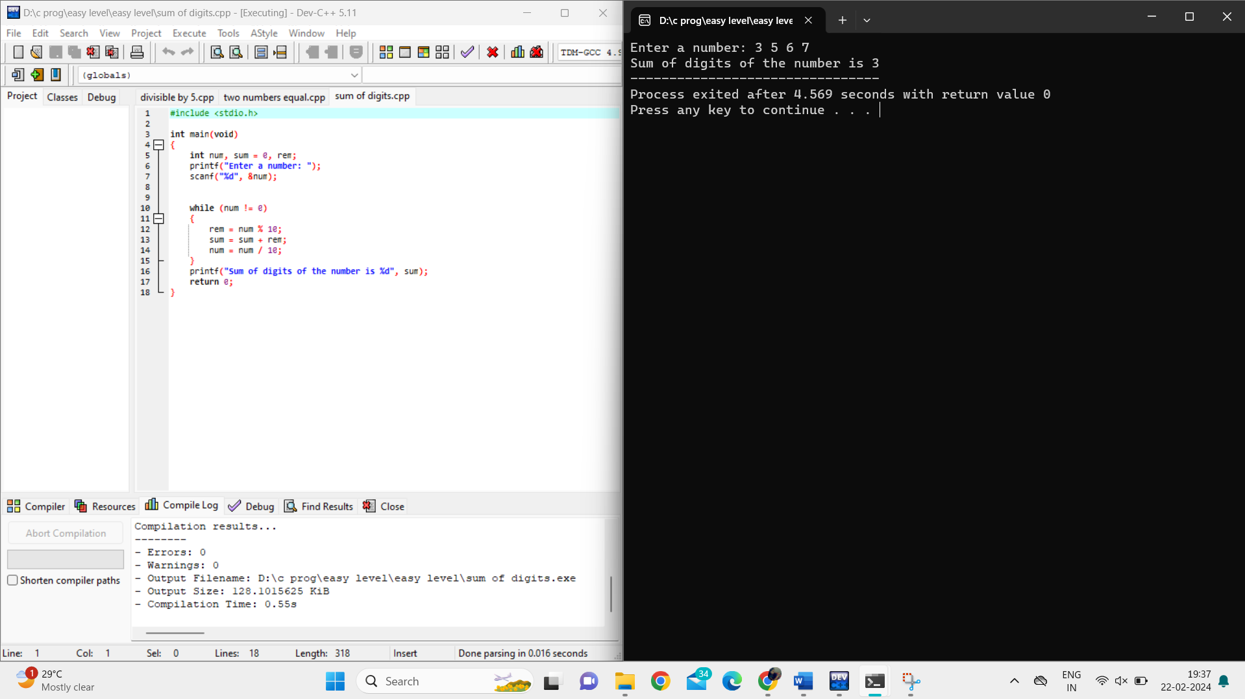

1. Increment by 1 to all the Digits of a Given Integer

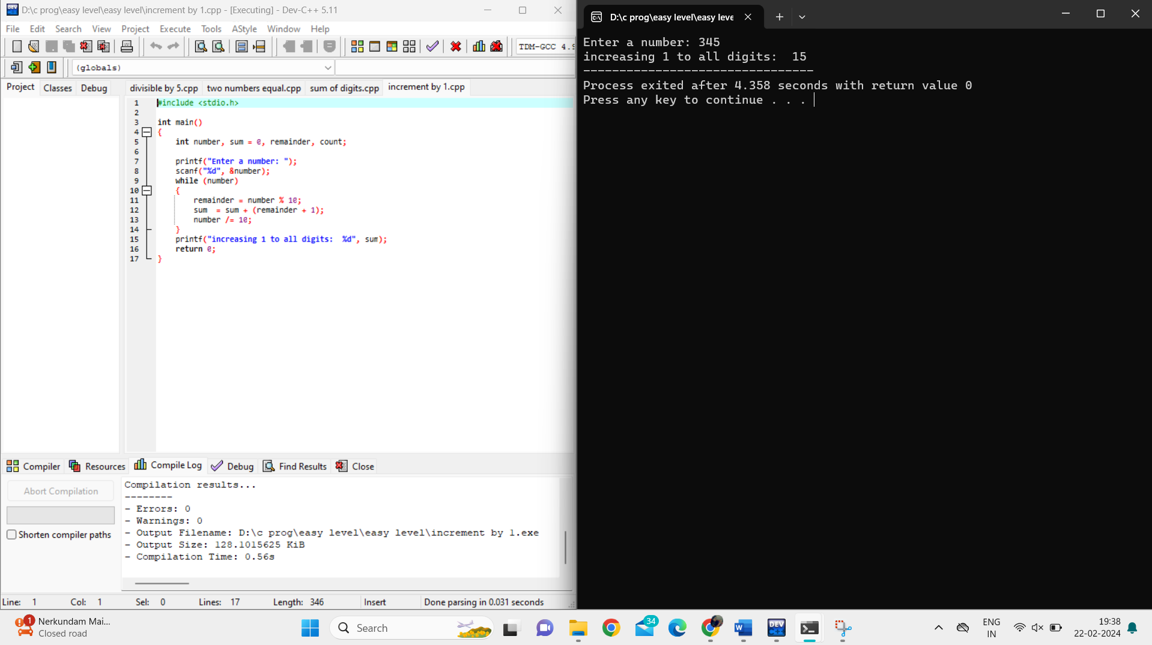

1. Multiplication Table
2. 